**4. installation of python**

I installed python version 3.12.3 by searching on the browser and clicking download….python sometimes is usually downloaded by default on windows but requires updating and you can check the version of python on your pc by opening git bash and running this command ‘python --version’

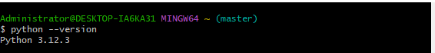

To run python certain parameters and extensions should be installed;

Pip

To install pip I typed ‘curl https://bootstrap.pypa.io/get-pip.py -o get-pip.py

python get-pip.py’

type ‘ pip –version’ to see the installed version

